MORE OLDIES BUT GOODIES
TSC Conferences
Toward a Science of Consciousness
2009 Hong Kong
- Ken Mogi, The Contingent Brain
- David Chalmers, The Extended Mind Revisited
- Chalmers on Science of Consciousness '07
- Stuart Hameroff, Quantum Perspective
- 2009 Photos

2007 SALZBURG
Quantum Mind 3
July 17-21, 2007
Gustav Bernroider, University of Salzburg


2007 BUDAPEST
Toward a Science of Consciousness
July 23-27, 2007
Budapest
George Kampis, Hungarian Foundation for
Cognitive Science, Eotvos University



2006 TUCSON
Toward a Science of Consciousness
April 4-8, 2006, Tucson, Arizona

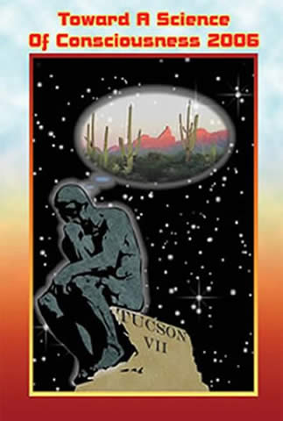
Chalmers on Neural Correlates '06
Abstracts, program etc., Click here
JCS Review "Are we studying consciousness yet?"
by Bill Faw
PHOTOS
Dave Chalmers' conference photos
http://consc.net/chalmers/
more photos from 2006
2004

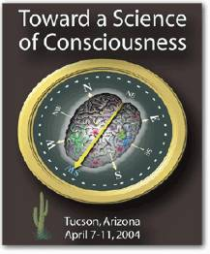

2002
2000
1998

other video and audio
in the can

TSC 1996
TSC 1996+
RetroCon

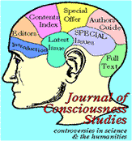
Moral Phenomenology
Workshop
Wrap-Up
Consciousness in Copenhagen
Picture Slide Show by Robert van Gulick
Archives

The Times Higher Education - April 1996
Consciousness Bulletin - 1997
Brain Mind Bulletin - 1994

Archives – disconnected
QUANTUM-MIND@LISTSERV.ARIZONA.EDU
http://listserv.arizona.edu/archives/quantum-mind/

